**Activity 1: AWS Lambda**

Brandon Trinkle

Information Technology, Arizona State University

IFT 320: Class Name

Professor Rahul Kashyap

9/15/2024

**Lab 1: Introduction to AWS IAM**

**Figure 1**

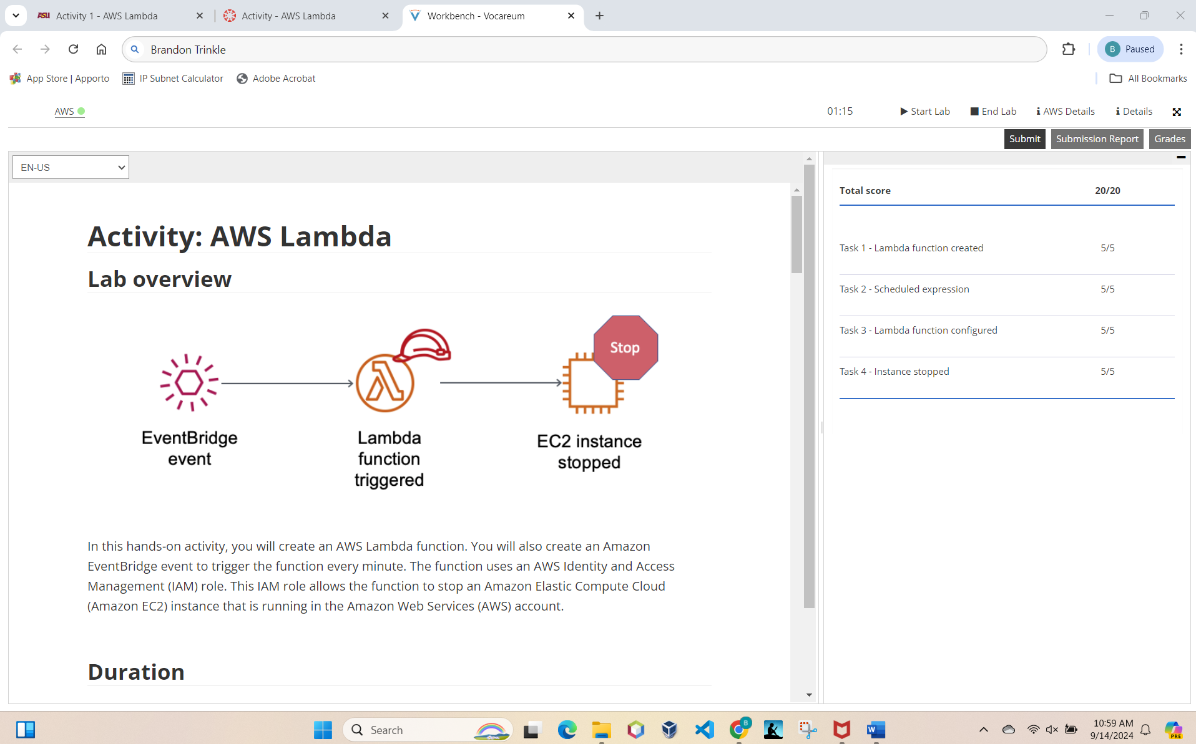

*Note*. AWS Activity 1 result, name included in URL.